Stroud District Council

Community Infrastructure Levy
Annual Report for Haresfield Parish Council
For the financial year 2024/2025





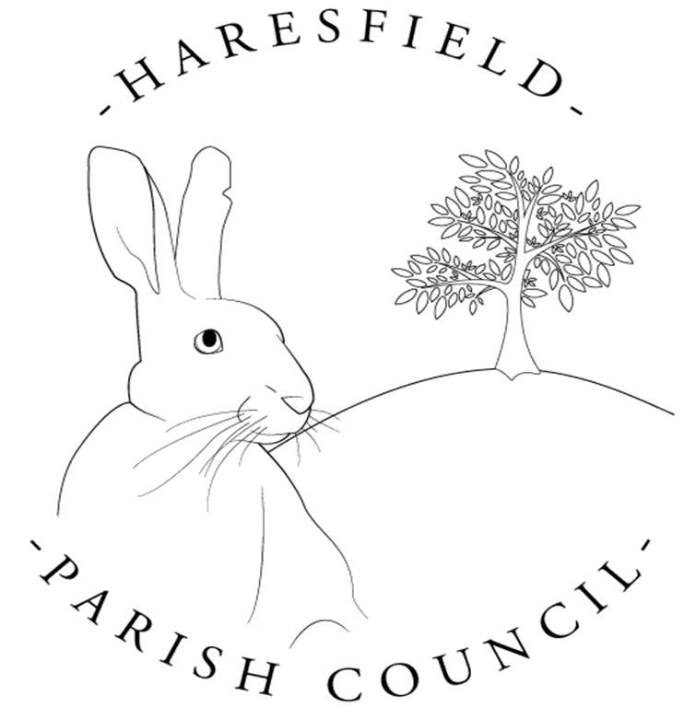

Haresfield Parish Council

Email: haresfieldpc@gmail.com

Website: https://haresfieldparishcouncil.gov.uk/

This report is published on (DATE) by Haresfield Parish Council in accordance with the CIL Regulations 2010 (as amended). Copies are made publicly available on our website https://haresfieldparishcouncil.gov.uk/reports-and-audits and this has been formally reported to our local CIL Charging Authority, Stroud District Council www.stroud.gov.uk.
Completed by: Madeleine King (Clerk)
Report for the financial year: 1st April 2024 – 31st March 2025
Payment Details | Amount
CIL Received – April 2024 | £ 0.00
CIL Received – October 2024 | £ 0.00
Total Received 2024/2025 | £ 0.00
Balance carried over from previous years | £ 335.89
Total Expenditure 2024/2025 | £ 0
Total Retained 2024/2025 | £ 0
Total held on account (all years) | £ 335.89

In line with the CIL legislation, Neighbourhood CIL receipts must not be kept on account unspent for more than 5 years from the date of receipt. This is monitored via annual reporting.

Expenditure Details
Neighbourhood CIL Project
Project Name:
Project Location:

Brief Description:

Date Project Completed:

Has the project been successful? Please include any pictures of the project you may have

Amount of CIL spent on the project: £
Total project costs: £
Summary of any match funding secured: £

All reports are available to view online at:
Town and Parish Councils - Neighbourhood CIL | Stroud District Council
CIL Reporting | Stroud District Council

